Kim Starr

**Part 2: Design**

1.Restaurant Name: “Zahhh’s” (as in Piz-zahhhh’s!)

2.Figma 3 low fidelity wireframes

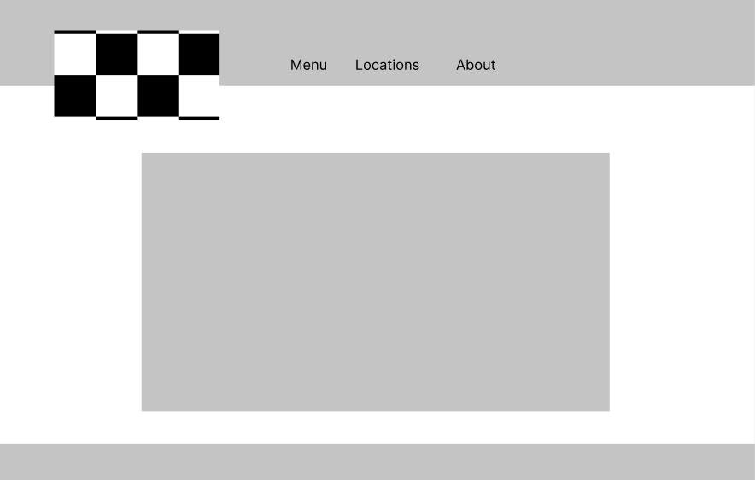

<https://www.figma.com/file/fYPBz6AL2AsE2D4ab0I01I/homepage-wireframe?node-id=0%3A1>

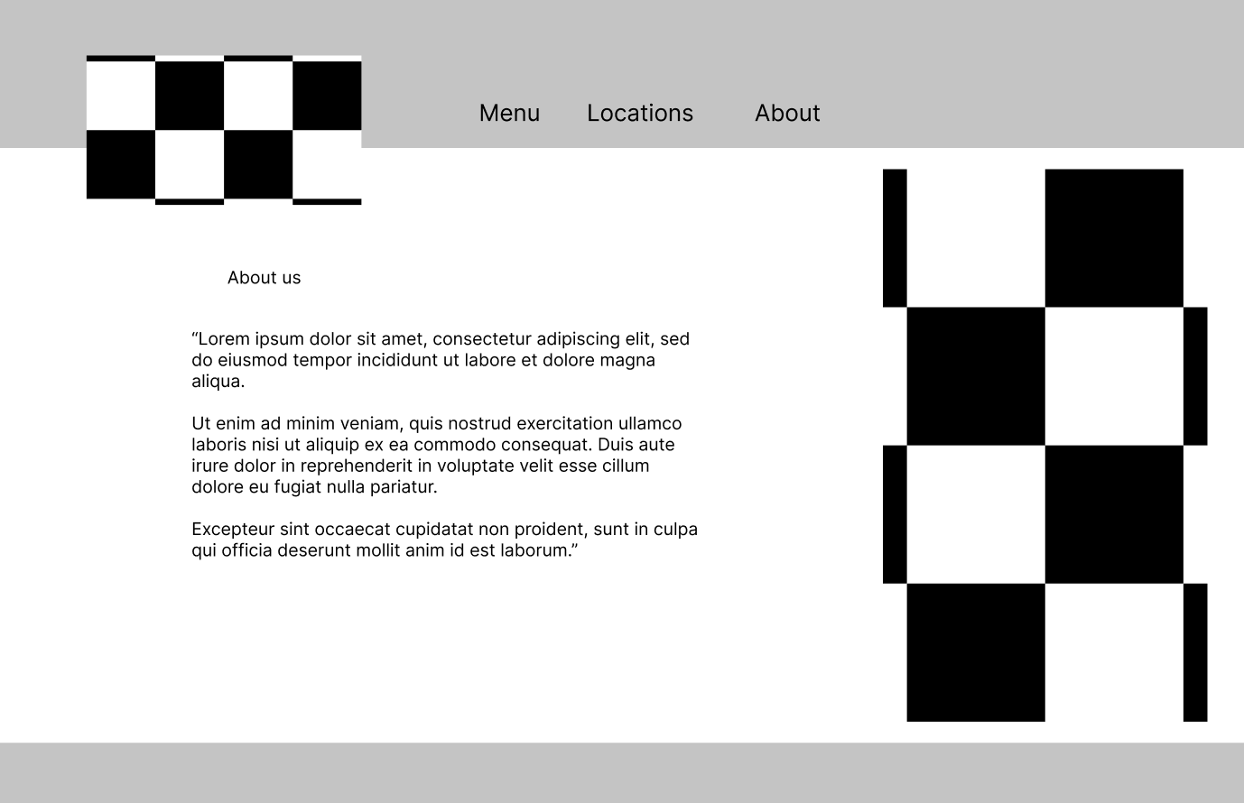

<https://www.figma.com/file/8yH1ZSnXXxuelLAW8TkEKL/about-wireframe?node-id=0%3A1>

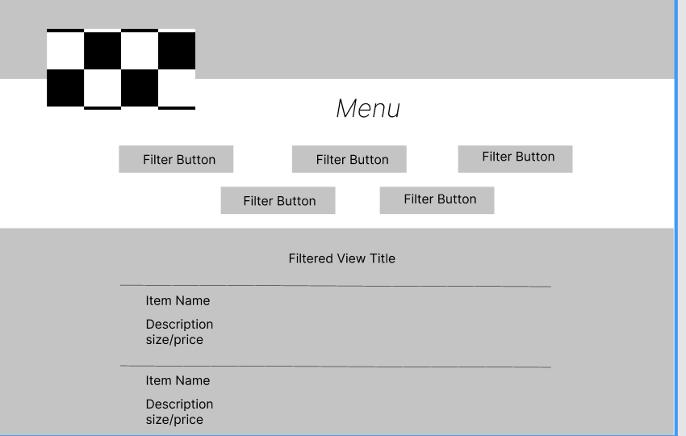

<https://www.figma.com/file/RhTh6rbzkjIoFI8iwCMFRN/assessment2.menuWireframe?node-id=0%3A1>

3. Style Guide:

**Color Scheme:**

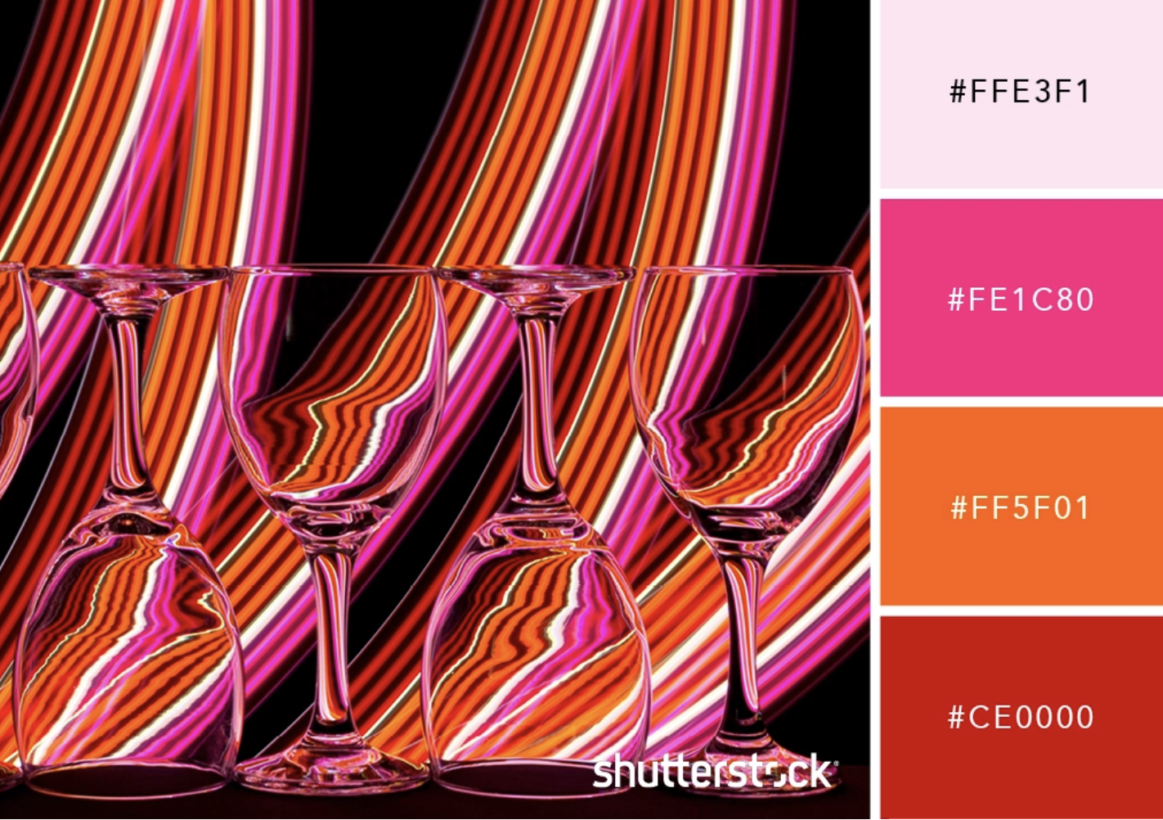

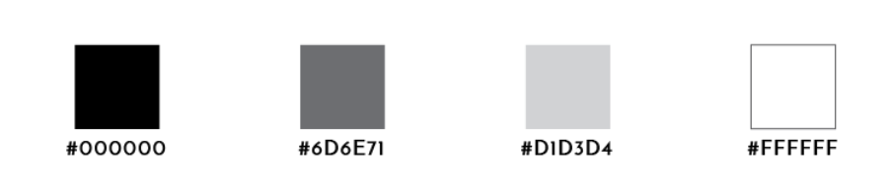

**Font-families:**

* ‘Permanent Marker’ for headers & titles
* ‘Montserrat’ for links & body

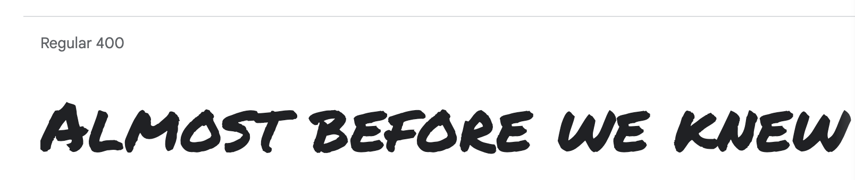

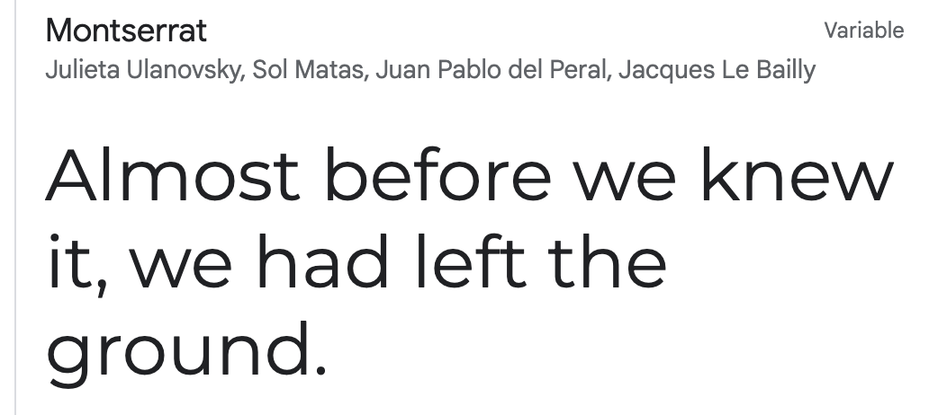

**Photos**:

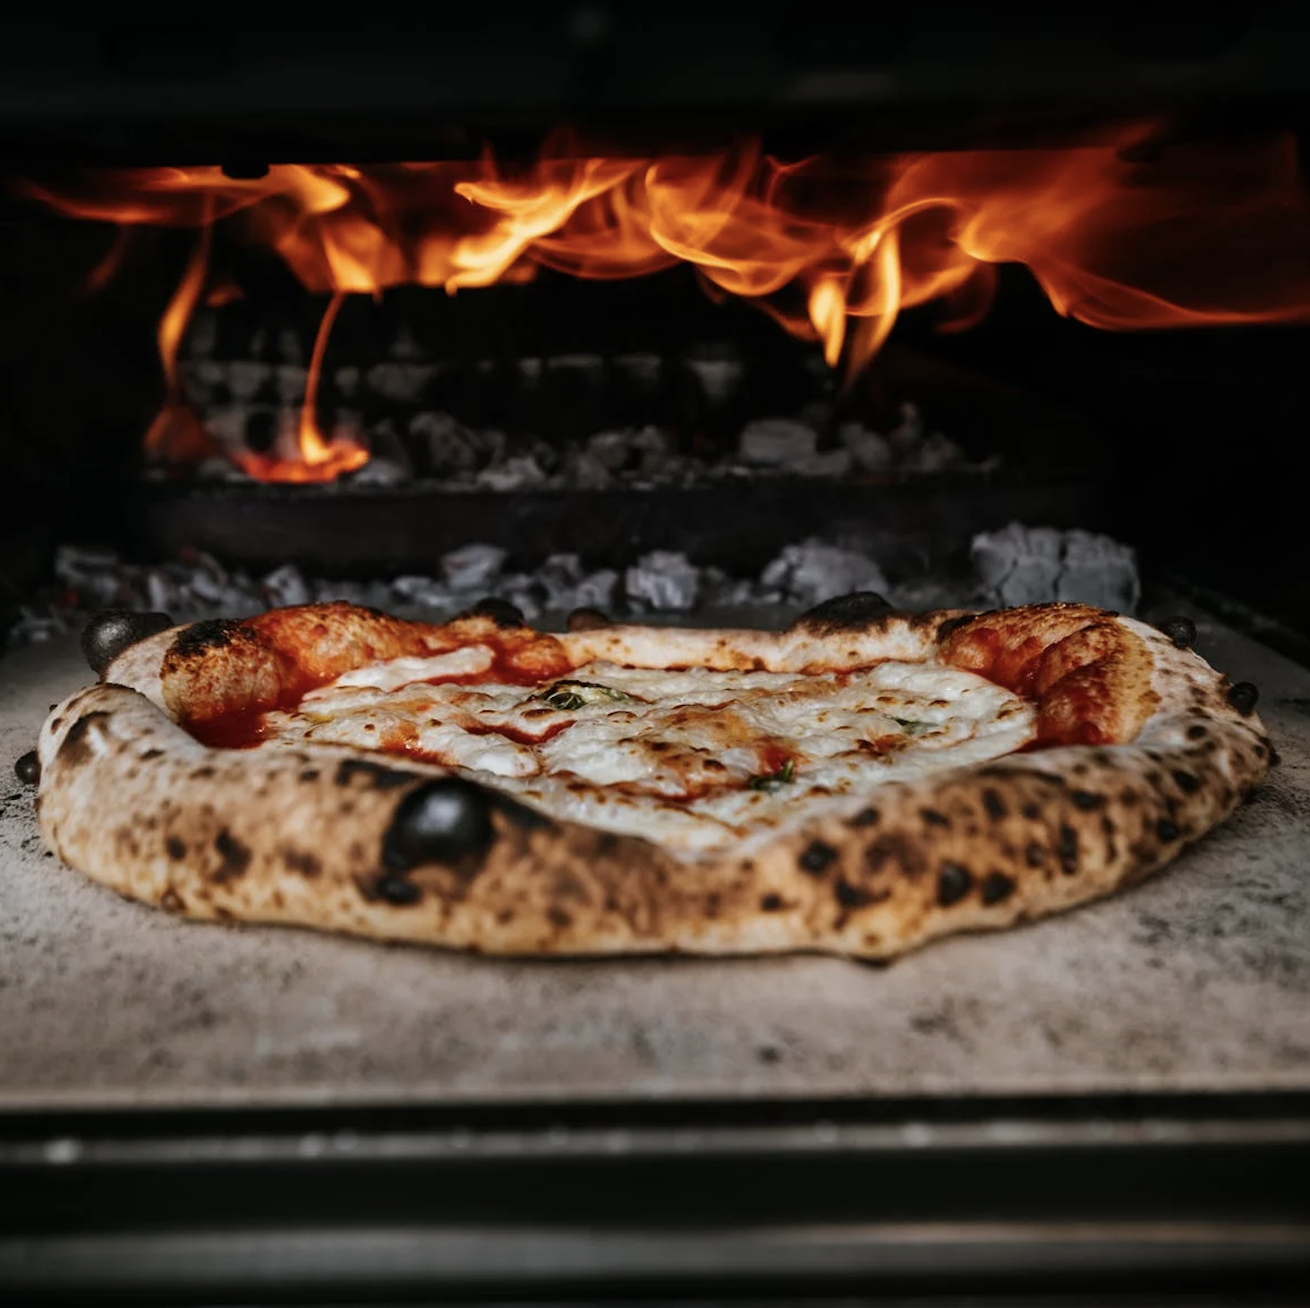 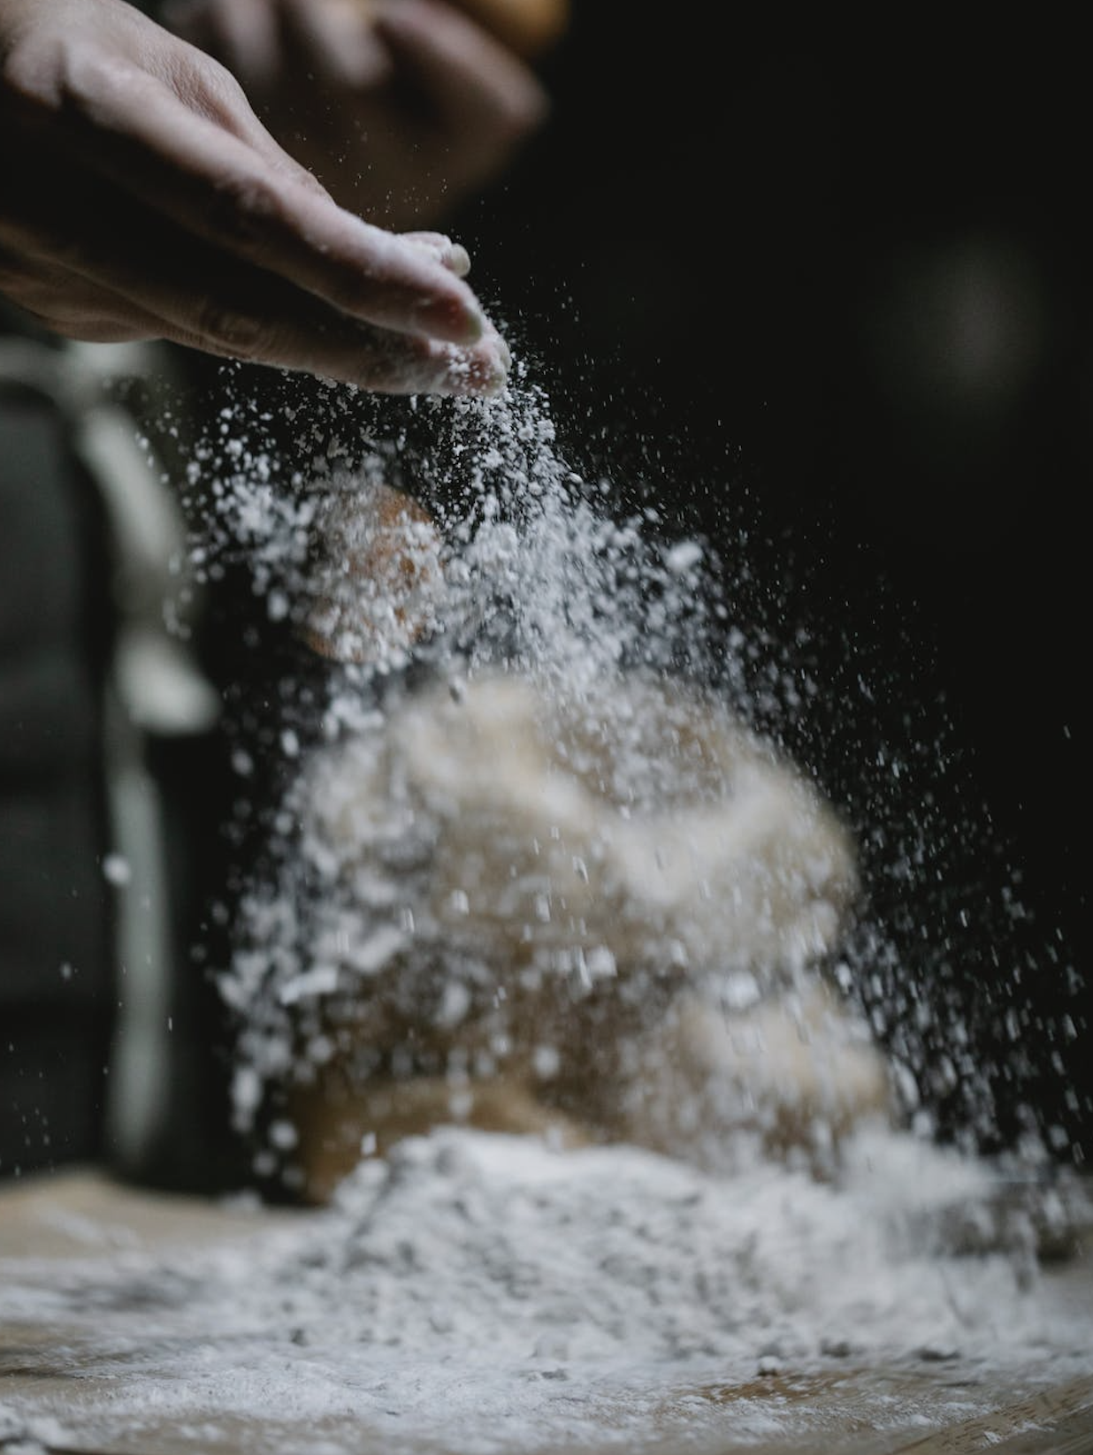 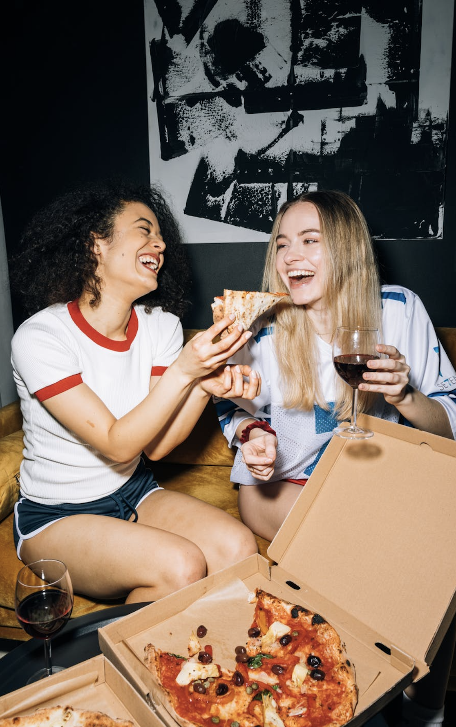

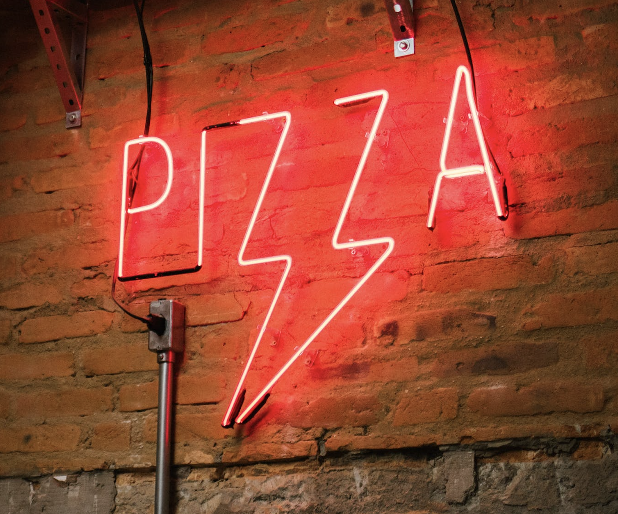 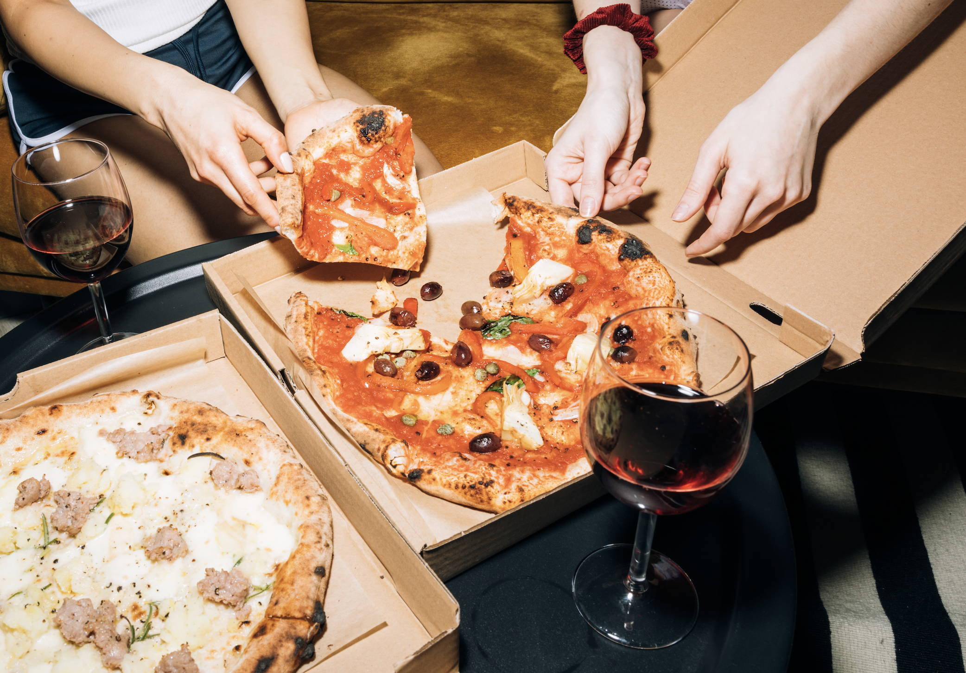

4.High-fidelity mockup:

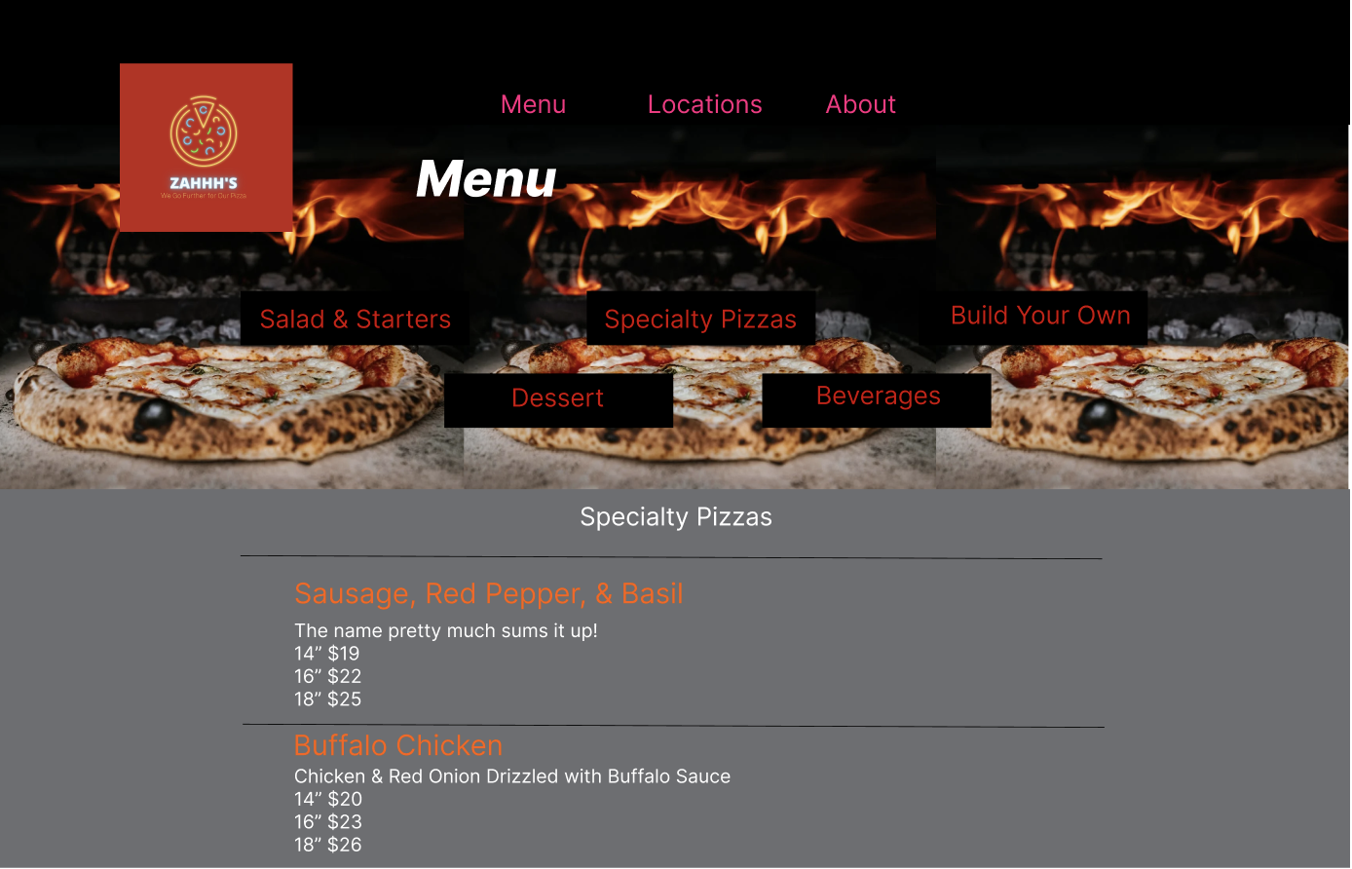

<https://www.figma.com/file/mhMgIkVfGWd4QGVJJ5CK3N/assessment2.menuWireframe---high-fidelity?node-id=0%3A1>